**Experiment -1.2**

**Student Name:** Akansh Arya **UID:** 22BDO10027

**Branch:** CSE(DevOps) **Section/Group:** 22BCD-1 A

**Semester:** 4TH **Date of Performance:** 24/01/2024

**Subject Name:** Git AND GitHub **Subject Code:** 22CSH-293

**1. Aim of the practical:** Creating branches with GitHub

**2. Software used:** Git Bash and GitHub.

**3. Hardware used:** Computer system.

**4. Steps of experiment:**

**For Creating branch on GitHub:**

**1.** Login to your GitHub profile on a browser.

**2.**  Click on the repository where you want to do branching.

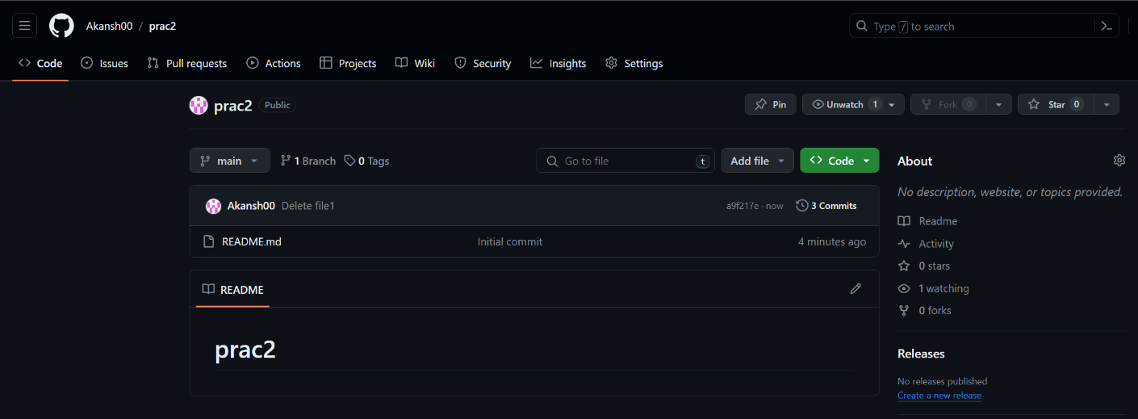 **3.** Click on **“Add file”** to add a new file.

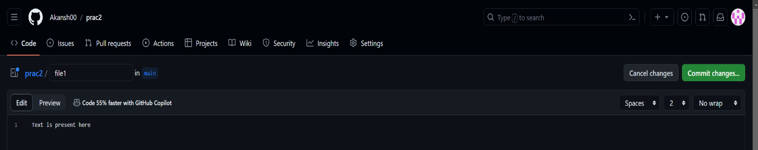 **4.** Give this file a name “**file1”** and add some text it.

**6.** Click on **“Commit changes”** button to commit the change.

**7.** Provide **“Commit message”** and **“Extended description”** then click **“Commit changes”**.

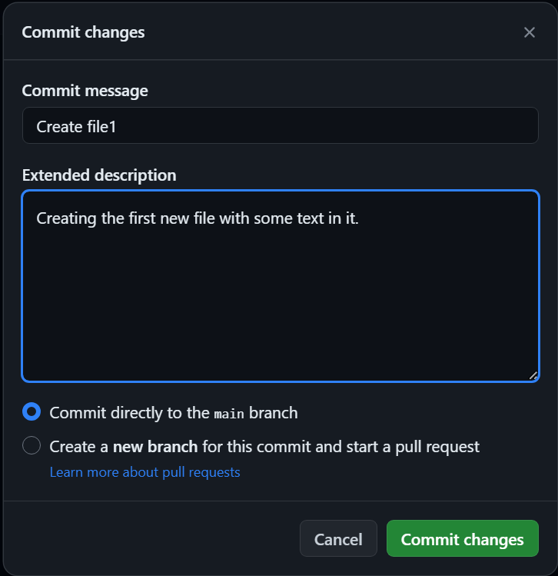

**8.** To create a new branch click on **“main”** that has a dropdown next to it.

**9.** Type a new branch name **“branch1”** and click **“Create branch branch1 from main”**

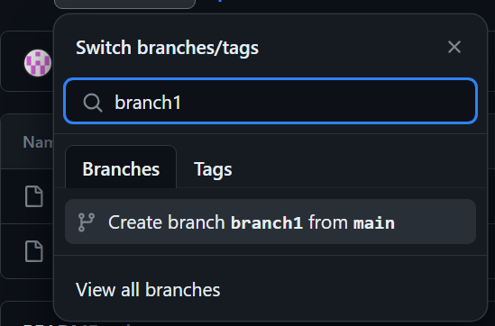

**10.** Click on the **“file1”** to open, then click on **“Edit this file”**.

**11.** Ater editing click on **“commit changes”** to commit the changes.

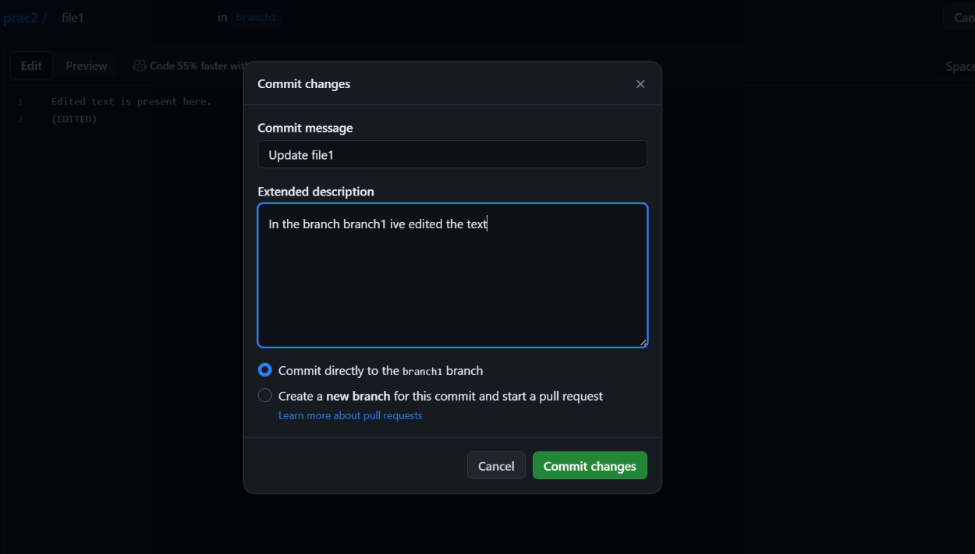**12.** Add **“Commit message”** and **“Extended description”** and then click on **“Commit changes”.**

**13.** After commiting the changes go to **“parent repository”** and click on **“Compare & pull request”.**

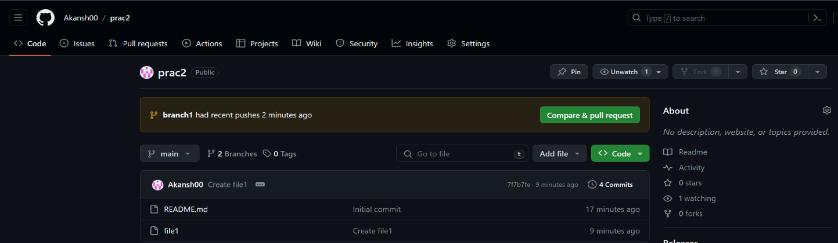

**14.** Scroll down and click on **“Split”** tocompare the text and get to know what has been changed.

**15.** Click on **“Create pull request”** And add **“title and description to code”**

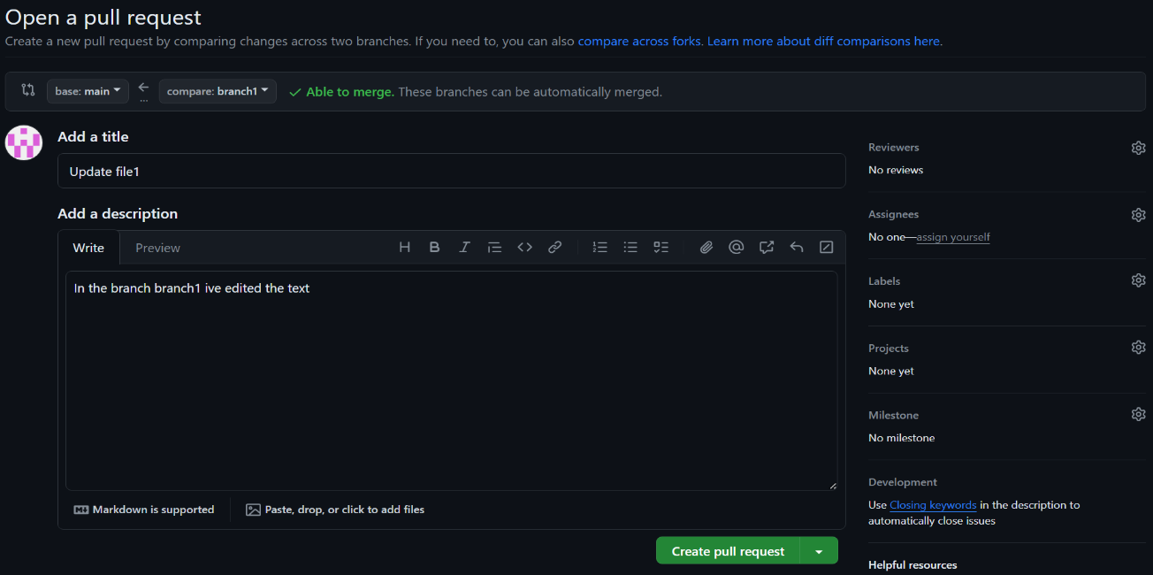

**16.** Click on **“Merge pull request”** and then confirm the merger by clicking **“Confirm merge”**

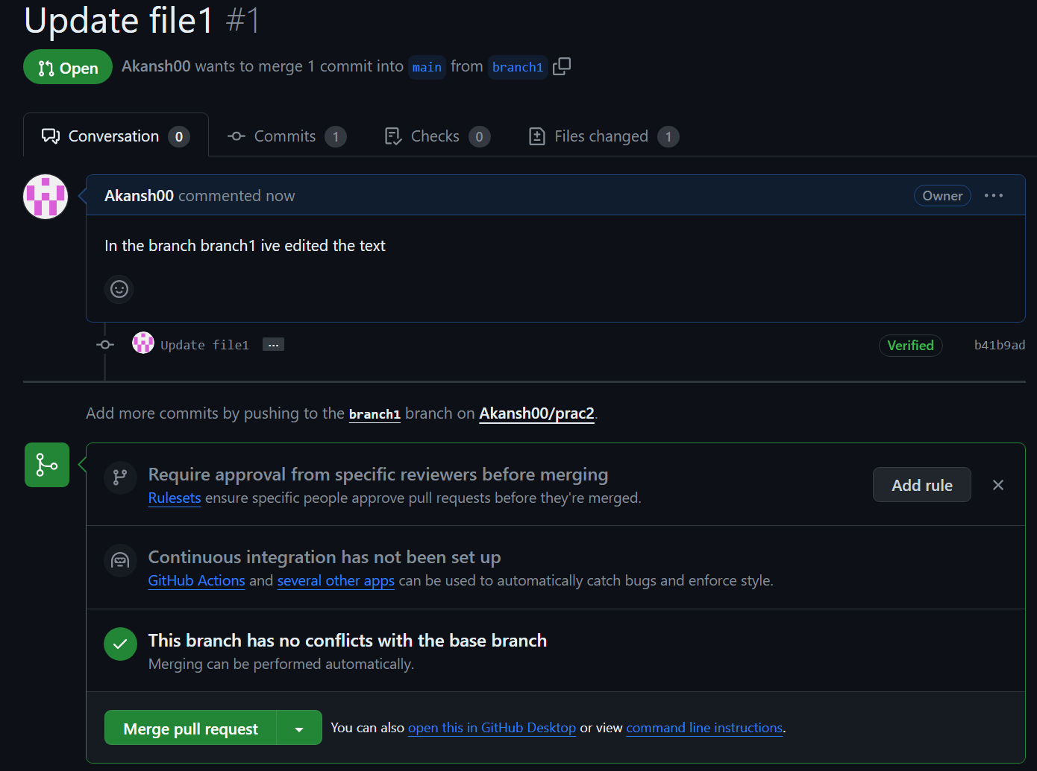

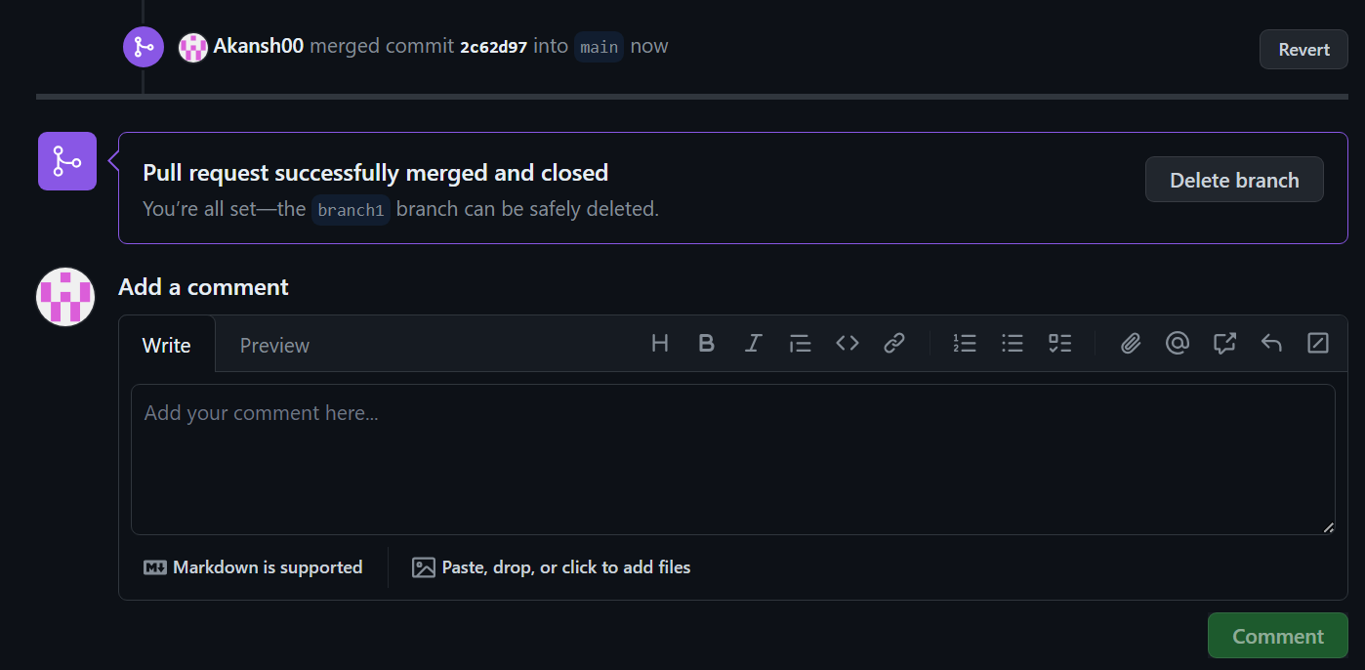**17.** After Merging the code Click on **“Delete branch”** if you wish to delete the branch.

**For Creating Branch on GitBash:**

1. Create a new directory **“folder2”** on desktop.
2. Initialize the git using **“git init”**command.

**3.** Create a new file **“touch text.txt”**

**4.** Edit file and add content to it.

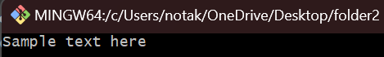

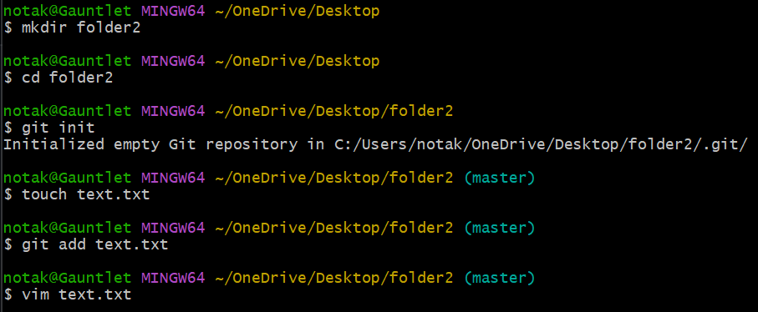**5.** Put the file in staging area **“git add text.txt”**

**6.** Commit this file using **“git commit -m “enter any commit message here””**.

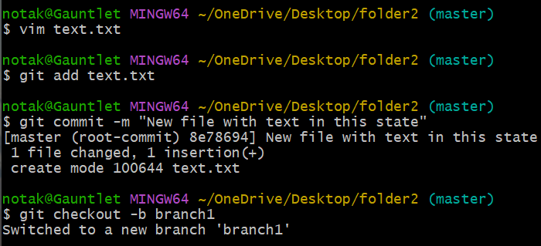**7.** Create a new branch using code **“git checkout -b branch1”**.

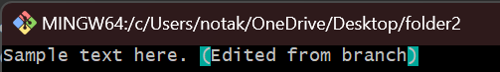**8.** Open and edit file using **“vim text.txt”**and add content to it.

**9.** Put the file in staging area **“git add text.txt”.**

**10.** Commit this file using **“git commit -m “enter any commit message here””.**

**11.** Move to master branch using **“git checkout master”.**

*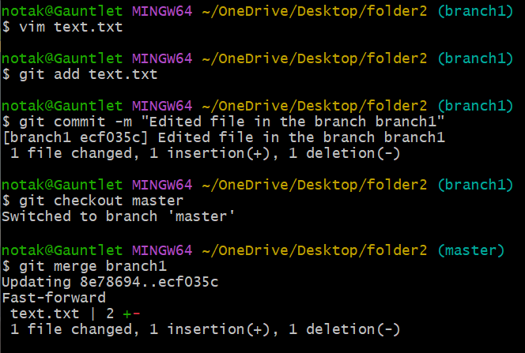***12.** Merge the branch **“git merge branch1”.**

*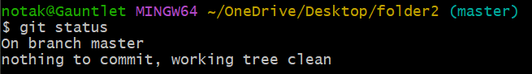***13.** Show the status of file **“git status”**.

**5. Result/Output/Writing Summary:**

In this experiment we worked with branches on the GitHub and also on our local repository. We created and deleted a branch and also to created and merged a pull request.

**Learning outcomes (What I have learnt):**

**1.** Learnt how to install git.

**2.** Learnt how to configure git with GitHub account.

**3.** Learnt about some basic commands such as cd and cat.

**4.** Learnt using git clone command.

**5.** Also learnt how to add and commit updates to the GitHub account.

**Evaluation Grid (To be created as per the SOP and Assessment guidelines by the faculty):**

|  |  |  |  |
| --- | --- | --- | --- |
| Sr. No. | Parameters | Marks Obtained | Maximum Marks |
| 1. |  |  |  |
| 2. |  |  |  |
| 3. |  |  |  |
|  |  |  |  |